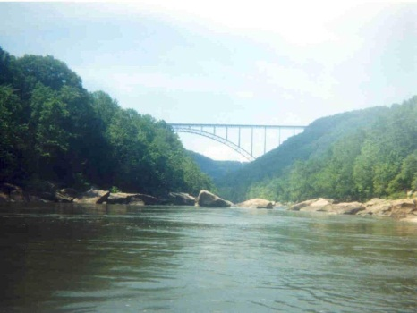
West Virginia Expanded School Mental Health Planning Retreat
December 11th and 12th, 2012
John 23rd Pastoral Center
Agenda

Tuesday, December 11, 2012
11:30 Lunch at Pastoral Center

1-1:15 Welcome and Introduction from Departments of Education and Behavioral Health:
Barb Ashcraft and Jackie Payne

1:15-1:45 Overview of ESMH in WV, Steering Committee Activities, Purpose for retreat, objectives:
Linda Anderson

1:45-2:15 Introductions and “School Mental Health Matters because…” activity

2:15-3:45 Specific initiatives/efforts relevant to forward planning

Department of Health and Human Resources
- ESMH: Tiffany Pittman
- System of Care: Jackie Payne
- Substance Abuse:
- Bureau for Children and Families: Jane McCallister
- Bureau for Public Health: Charlotte Flanagan

WV Department of Education
- Office of Healthy Schools: Keith Burdette, Don Chapman, Cybele Boehm
  - Policy 4373, Safe and Supportive Schools Grantees, Regional Wellness Coordinators
- Office of School Improvement/School Counseling: Barb Ashcraft
- Office of Optional Education Pathways (Alternative Ed, Dropout Prevention): Shelly DeBerry
- Office of Special Programs
- PBIS: Pat Homberg / Matt Dotson
- School Medicaid Billing: Vicky Mohnacky

Marshall University: Richard Crespo, Stephanie Hayes
- Role of School Health Technical Assistance Center
- Evaluation of ESMH Grants

Local Examples: Three local examples of SMH evolution : Margy Burns, Helen Wells, Jessica Laslo

Others: Youth and Family Involvement /Engagement
FQHCs

3:45-4 Wrap Up, Plans for Day 2

Wednesday, December 12, 2012

8:30-8:45 Reflections on Day 1

8:45 – 9:30 Survey Results
Revisit current goals – Do we need to refine? Are we missing any?

9:30 – 10:30 Goals 1 & 2 – Establish action steps and prioritize

10:30-10:45 BREAK

10:45 – 11:45 Goals 3 & 4 – Establish action steps and prioritize

11:45 – 12:45 LUNCH

12:45 – 1:45 Goals 5 & 6 – Establish action steps and prioritize

1:45 – 2:45 Goal 7 (and any newly established goal) – Establish action steps and prioritize

2:45 – 3 Wrap up and Next Steps

