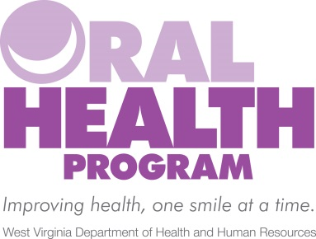
OMCFH Main Reception Line: 304-558-5388
Oral Health Fax Line: 304-558-2183
Name | Position | Direct Line (in office, dial “7” + last four digits)
Jason Roush, DDS | State Dental Director  Program Director | 304-356-4353
Teresa Marks | Program Manager | 304-356-4233
Vacant | Program Secretary | 304-356-4419
Adult Services
Pre-Employment & Donated Denture Projects
Charlene Hickman | Adult Services Supervisor | 304-356-4313
Ken Selbe | Adult Services Specialist | 304-356-4429
Zara Sheikh | Adult Services Specialist | 304-356-4458
Tiffany Keith | Adult Services Assistant | 304-356-4423
Oral Health Prevention
Janna Thornsbury, RDH | Prevention Coordinator | 304-356-4464
Kellyn Blair | Outreach Worker | 304-356-4391
Oral Health Workforce
Julie Jackson, RDH | Workforce Coordinator | 304-356-4367
Butch Varchetto, DDS | Technical Assistance Team | Out-stationed
Barb Thaxton, RDH | Technical Assistance Team | Out-stationed
Kay Dunn | Technical Assistance Team | Out-stationed
Kim McDowell | Technical Assistance Team | Out-stationed

To transfer calls to an extension in office:
- Push “TRANSFER” button (bottom right of phone)
- Dial 7 + four digit extension
- After ring, push “TRANSFER” button again
- Hang up phone receiver

